n

## Test Two­­­

## Semester One 2018 UNIT 1 METHODS

## Calculator Free 40 minutes /40 marks

## Formula Sheet is permitted

**Name:**

Place a tick in the box next to your Mathematics teachers name:

|  |  |
| --- | --- |
| **Mr Strain** | **□** |
| **Ms Sindel** | **□** |
| **Mrs Rimando** | **□** |
| **Mr Gannon** | **□** |
| **Mr Young** | **□** |
| **Mrs Flynn** | **□** |
| **Ms Ensly** | **□** |
|  |  |

**Question 1 (4, 2, 2 = 8 marks)**

Given ${\left(y+1\right)}^{2}=2x-1$,

1. sketch the graph of the equation.

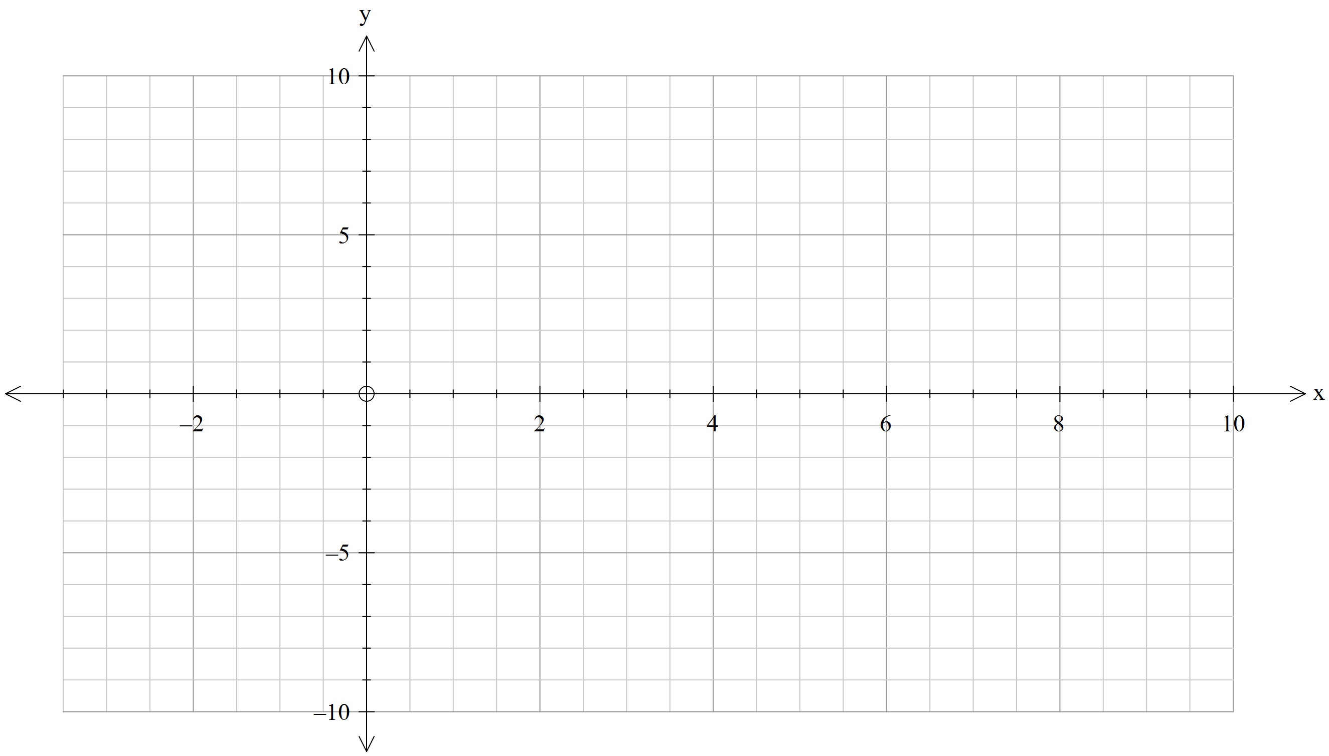

1. state its domain and range.
2. Is this graph a function? Justify.

**Question 2 (4, 3 = 7 marks)**

The function $f\left(x\right)=\sqrt{x}$ undergoes several transformations that result to $g\left(x\right)$ as represented in the graphs below.

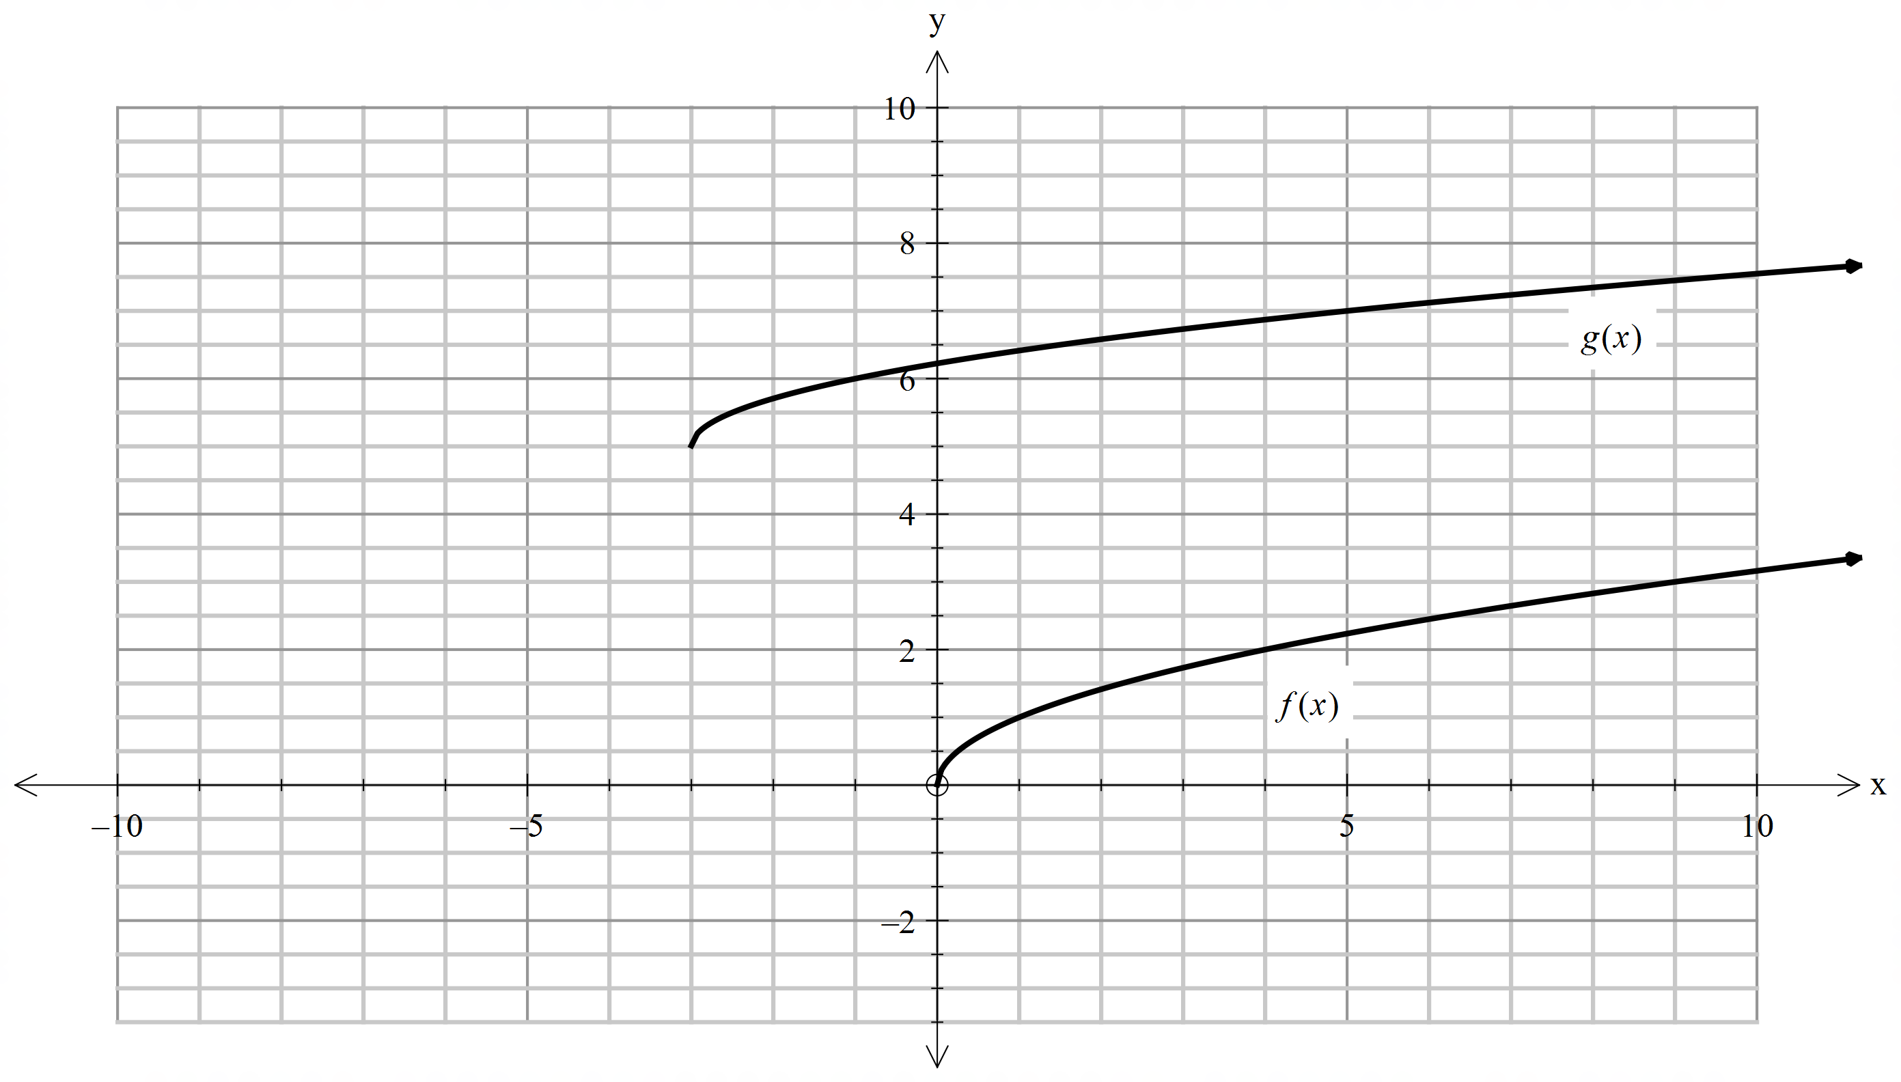

1. Identify the order of transformations that would transform $f(x)$ to $g(x)$.
2. Write the equation of the resulting function $g\left(x\right).$

**Question 3 (2, 2 = 4 marks)**

A circle has its centre at $(-2,-3)$ and passes through the point $\left(1,1\right).$

1. What is the radius of this circle?
2. State the equation of the circle in expanded form.

**Question 4 (3, 3 = 6 marks)**

Write the equations of the following graphs:

i)

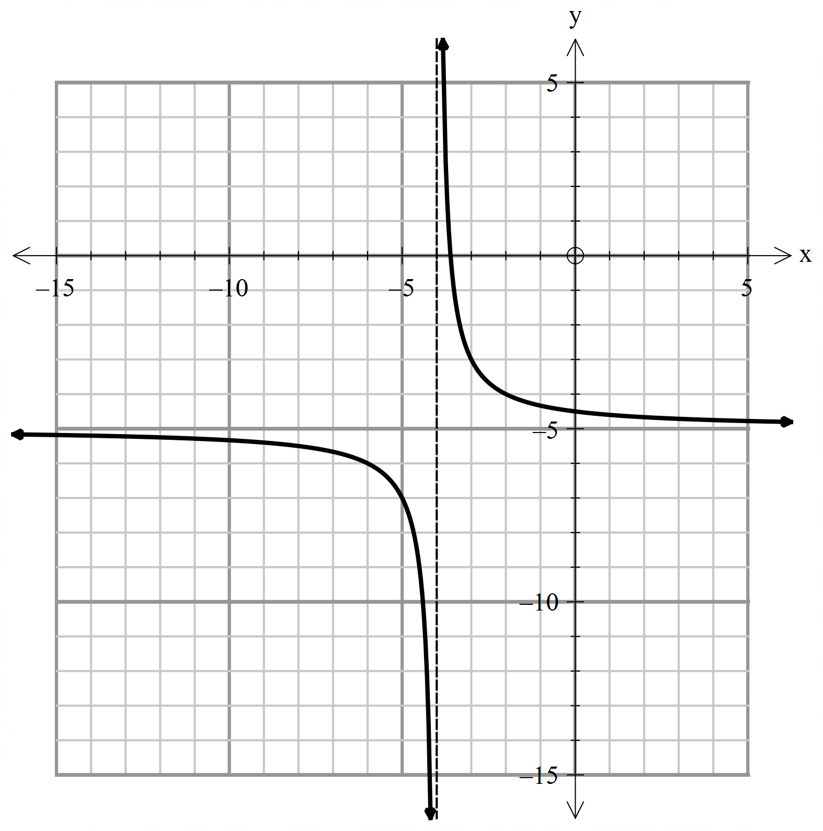

ii) 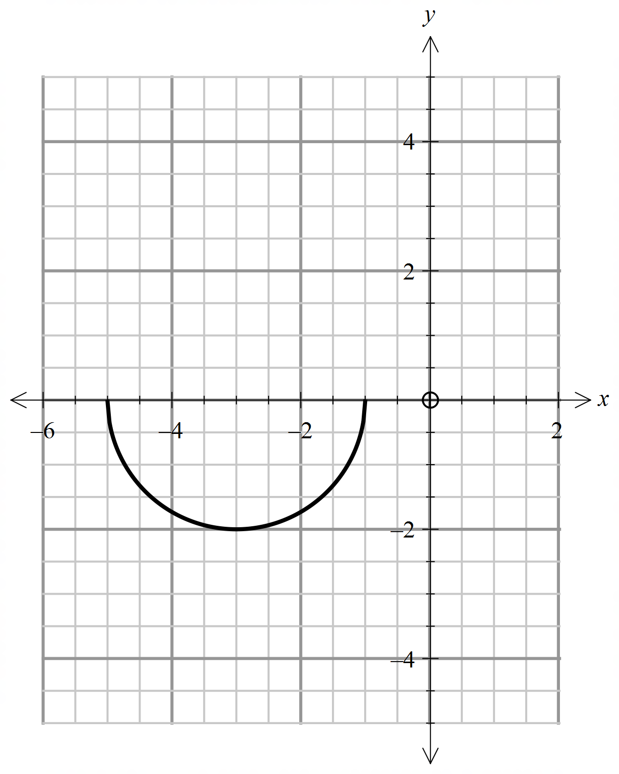

**Question 5 (2, 2, 2 = 6 marks)**

A pebble is thrown vertically upwards. It has an initial speed of $u$ metres per second. The pebble reaches a maximum height of $h$ metres before falling vertically downwards. It is known that $h$ is directly proportional to $u^{2}$. When the pebble is thrown with an initial speed of $10 m/s$, it reaches a maximum height of $5$ meters.

1. Write an equation that models this relationship.
2. Calculate the maximum height reached when the pebble is thrown with an initial speed of $12 m/s$.
3. Find the initial speed of the pebble if the maximum height reached is $16$ meters. Write your answer as an exact value.

**Question 6 (4 marks)**

State whether the relationships given below model a direct variation, inverse variation or neither.

$y=7x-2$

1. The number of hours to finish a job and the number of workers.

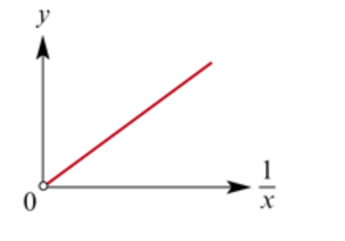

|  |  |  |  |
| --- | --- | --- | --- |
| x | 1 | 2 | 3 |
| y | 5 | 2.5 | 1 |

**Question 7 (1, 4 =5 marks)**

There are 100 people in an evacuation centre. Supplies for food are being rationed and their supply will last for 20 days.

1. Write a variation statement that relates the number of days for food supplies $f$, to the number of people, $p.$
2. Suppose 25 more people are evacuated in the same centre. At the very latest, on what day should their supplies be replenished?

**End of test**